YubiKey Factory Reset

Objective
Perform a factory reset (FIDO2) on a YubiKey, allowing the device to be redistributed to another user.

Prerequisites
- Account with session elevation (-PD) available.
- YubiKey connected via USB.

Step-by-Step
- Access the Yubico Authenticator download site:
https://www.yubico.com/products/yubico-authenticator/
- Download based on your operating system.
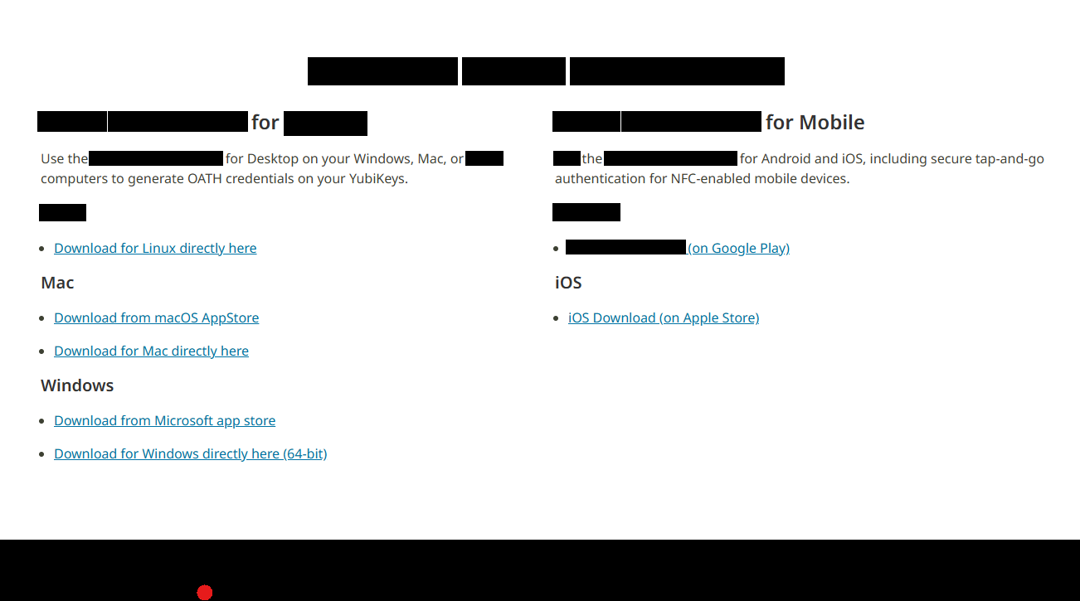
- Run the installer after downloading.
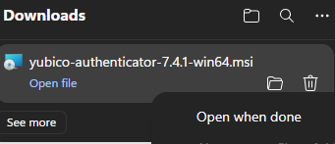
- Proceed through the installation.
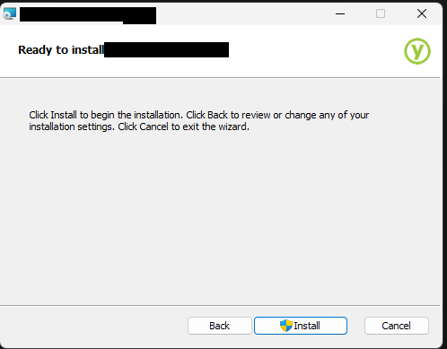
- Open the Yubico Authenticator application and click Factory reset with the YubiKey connected.
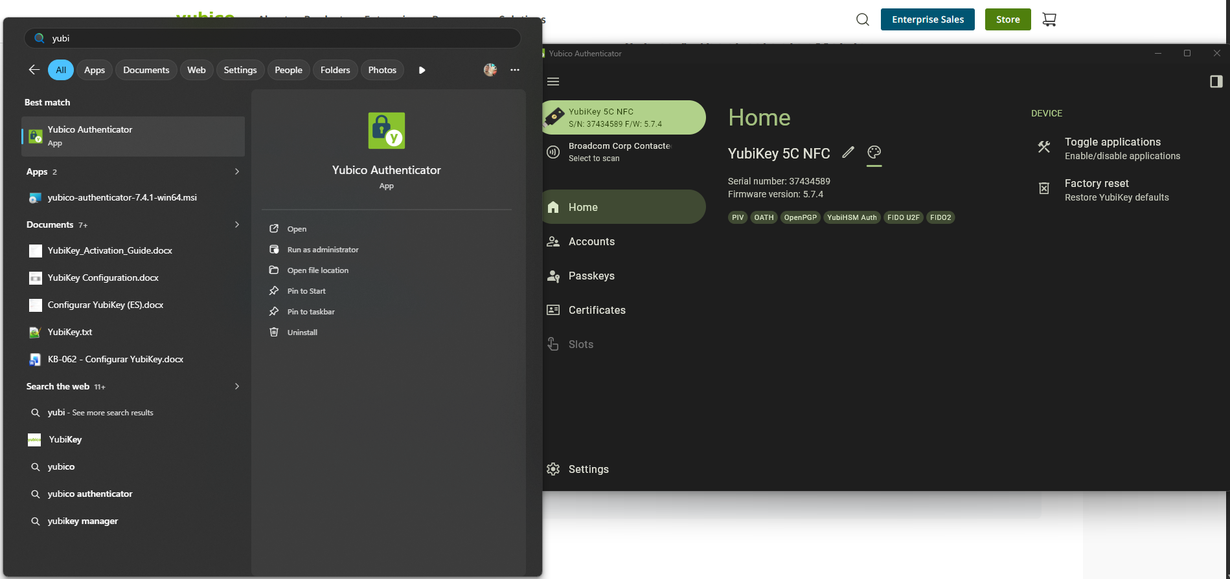
- Select the FIDO2 option and click Request Access. Session elevation will be requested — use the -PD account. Then click Reset.
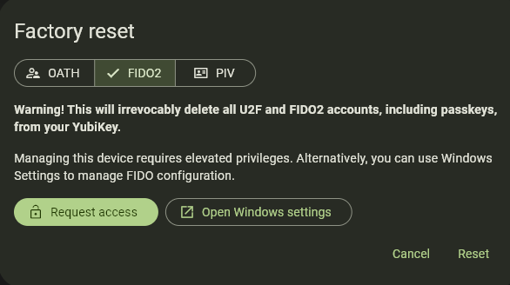
- Follow the on-screen instructions to remove and reconnect the YubiKey. The reset will be complete. The device can be stored or redistributed to another user.

Version History
Author | Version | Date | Description
Lucas Souza | 1.0 | Jun/2026 | Document creation

